**Done by: Shen Yang (All queries)**

**GTID: 902912328**

Query 1:

SELECT A1.Store_Nbr, A1.Store_Name, A2.Sum_Of_TVA

FROM

(SELECT Store_Nbr, Store_Name FROM store_information WHERE State = 'FL') A1

LEFT JOIN

(SELECT Store_Nbr, SUM(Total_Visit_Amt) Sum_Of_TVA FROM store_visits GROUP BY Store_Nbr) A2

ON A1.Store_Nbr = A2.Store_Nbr

ORDER BY A1.Store_Nbr

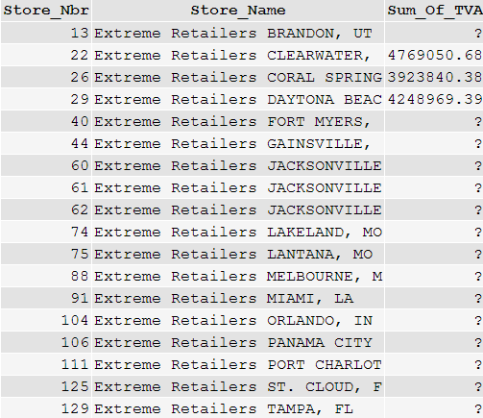

Query 2:

SELECT x.Week, x.Store_Nbr, x.StorePerWeekTotal, z.WeekTotal, q.StoreTotal, w.TotalTotal FROM

(SELECT c.Week, SUM(Total) WeekTotal FROM

(SELECT b.Store_Nbr, b.Week, SUM(b.Total_Visit_Amt) Total FROM

(SELECT Store_Nbr FROM store_information WHERE State='FL') a

INNER JOIN

(SELECT ROUND((EXTRACT(DAY FROM Transaction_Date)-1)/7+1,0) AS Week, Store_Nbr, Total_Visit_Amt FROM store_visits

WHERE EXTRACT(MONTH FROM Transaction_Date)=1 AND EXTRACT(YEAR FROM Transaction_Date)=2000) b

ON a.Store_Nbr = b.Store_Nbr

GROUP BY b.Store_Nbr, b.Week) c

GROUP BY c.Week) z

FULL JOIN

(SELECT b.Store_Nbr, b.Week, SUM(b.Total_Visit_Amt) StorePerWeekTotal FROM

(SELECT Store_Nbr FROM store_information WHERE State='FL') a

INNER JOIN

(SELECT ROUND((EXTRACT(DAY FROM Transaction_Date)-1)/7+1,0) AS Week, Store_Nbr, Total_Visit_Amt FROM store_visits

WHERE EXTRACT(MONTH FROM Transaction_Date)=1 AND EXTRACT(YEAR FROM Transaction_Date)=2000) b

ON a.Store_Nbr = b.Store_Nbr

GROUP BY b.Store_Nbr, b.Week) x

ON z.Week = x.Week

FULL JOIN

(SELECT b.Store_Nbr, SUM(b.Total_Visit_Amt) StoreTotal FROM

(SELECT Store_Nbr FROM store_information WHERE State='FL') a

INNER JOIN

(SELECT ROUND((EXTRACT(DAY FROM Transaction_Date)-1)/7+1,0) AS Week, Store_Nbr, Total_Visit_Amt FROM store_visits

WHERE EXTRACT(MONTH FROM Transaction_Date)=1 AND EXTRACT(YEAR FROM Transaction_Date)=2000) b

ON a.Store_Nbr = b.Store_Nbr

GROUP BY b.Store_Nbr) q

ON q.Store_Nbr = x.Store_Nbr

CROSS JOIN

(SELECT SUM(Total) TotalTotal FROM

(SELECT b.Store_Nbr, b.Week, SUM(b.Total_Visit_Amt) Total FROM

(SELECT Store_Nbr FROM store_information WHERE State='FL') a

INNER JOIN

(SELECT ROUND((EXTRACT(DAY FROM Transaction_Date)-1)/7+1,0) AS Week, Store_Nbr, Total_Visit_Amt FROM store_visits

WHERE EXTRACT(MONTH FROM Transaction_Date)=1 AND EXTRACT(YEAR FROM Transaction_Date)=2000) b

ON a.Store_Nbr = b.Store_Nbr

GROUP BY b.Store_Nbr, b.Week) f) w

ORDER BY x.Week, x.Store_Nbr

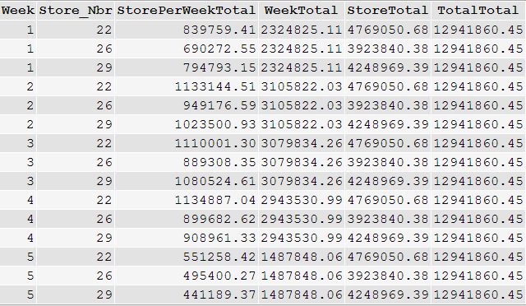

Query 3:

SELECT z.Week, z.Store_Nbr, z.Total, z.Ranking FROM

(SELECT c.GRanking, c.Week, c.Store_Nbr, c.Total, RANK() OVER(ORDER BY c.Total DESC) As Ranking FROM

(SELECT RANK() OVER(ORDER BY SUM(a.Total_Visit_Amt) DESC) As GRanking, a.Week, a.Store_Nbr, SUM(a.Total_Visit_Amt) Total FROM

(SELECT ROUND((EXTRACT(DAY FROM Transaction_Date)-1)/7+1,0) AS Week, Store_Nbr, Total_Visit_Amt FROM store_visits

WHERE EXTRACT(MONTH FROM Transaction_Date)=1 AND EXTRACT(YEAR FROM Transaction_Date)=2000) a

LEFT JOIN

(SELECT Store_Nbr, State FROM store_information) b

ON a.Store_Nbr = b.Store_Nbr

WHERE b.State='FL'

GROUP BY a.Week, a.Store_Nbr) c

WHERE c.Week = 1

UNION

SELECT c.GRanking, c.Week, c.Store_Nbr, c.Total, RANK() OVER(ORDER BY c.Total DESC) As Ranking FROM

(SELECT RANK() OVER(ORDER BY SUM(a.Total_Visit_Amt) DESC) As GRanking, a.Week, a.Store_Nbr, SUM(a.Total_Visit_Amt) Total FROM

(SELECT ROUND((EXTRACT(DAY FROM Transaction_Date)-1)/7+1,0) AS Week, Store_Nbr, Total_Visit_Amt FROM store_visits

WHERE EXTRACT(MONTH FROM Transaction_Date)=1 AND EXTRACT(YEAR FROM Transaction_Date)=2000) a

LEFT JOIN

(SELECT Store_Nbr, State FROM store_information) b

ON a.Store_Nbr = b.Store_Nbr

WHERE b.State='FL'

GROUP BY a.Week, a.Store_Nbr) c

WHERE c.Week = 2

UNION

SELECT c.GRanking, c.Week, c.Store_Nbr, c.Total, RANK() OVER(ORDER BY c.Total DESC) As Ranking FROM

(SELECT RANK() OVER(ORDER BY SUM(a.Total_Visit_Amt) DESC) As GRanking, a.Week, a.Store_Nbr, SUM(a.Total_Visit_Amt) Total FROM

(SELECT ROUND((EXTRACT(DAY FROM Transaction_Date)-1)/7+1,0) AS Week, Store_Nbr, Total_Visit_Amt FROM store_visits

WHERE EXTRACT(MONTH FROM Transaction_Date)=1 AND EXTRACT(YEAR FROM Transaction_Date)=2000) a

LEFT JOIN

(SELECT Store_Nbr, State FROM store_information) b

ON a.Store_Nbr = b.Store_Nbr

WHERE b.State='FL'

GROUP BY a.Week, a.Store_Nbr) c

WHERE c.Week = 3

UNION

SELECT c.GRanking, c.Week, c.Store_Nbr, c.Total, RANK() OVER(ORDER BY c.Total DESC) As Ranking FROM

(SELECT RANK() OVER(ORDER BY SUM(a.Total_Visit_Amt) DESC) As GRanking, a.Week, a.Store_Nbr, SUM(a.Total_Visit_Amt) Total FROM

(SELECT ROUND((EXTRACT(DAY FROM Transaction_Date)-1)/7+1,0) AS Week, Store_Nbr, Total_Visit_Amt FROM store_visits

WHERE EXTRACT(MONTH FROM Transaction_Date)=1 AND EXTRACT(YEAR FROM Transaction_Date)=2000) a

LEFT JOIN

(SELECT Store_Nbr, State FROM store_information) b

ON a.Store_Nbr = b.Store_Nbr

WHERE b.State='FL'

GROUP BY a.Week, a.Store_Nbr) c

WHERE c.Week = 4

UNION

SELECT c.GRanking, c.Week, c.Store_Nbr, c.Total, RANK() OVER(ORDER BY c.Total DESC) As Ranking FROM

(SELECT RANK() OVER(ORDER BY SUM(a.Total_Visit_Amt) DESC) As GRanking, a.Week, a.Store_Nbr, SUM(a.Total_Visit_Amt) Total FROM

(SELECT ROUND((EXTRACT(DAY FROM Transaction_Date)-1)/7+1,0) AS Week, Store_Nbr, Total_Visit_Amt FROM store_visits

WHERE EXTRACT(MONTH FROM Transaction_Date)=1 AND EXTRACT(YEAR FROM Transaction_Date)=2000) a

LEFT JOIN

(SELECT Store_Nbr, State FROM store_information) b

ON a.Store_Nbr = b.Store_Nbr

WHERE b.State='FL'

GROUP BY a.Week, a.Store_Nbr) c

WHERE c.Week = 5) z

ORDER BY z.Week, z.Store_Nbr

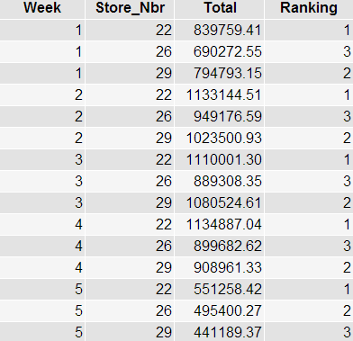

Query 4:

SELECT Store_Nbr, Membership_Nbr FROM store_visits

GROUP BY Store_Nbr, Membership_Nbr

HAVING COUNT(*) > 1000

ORDER BY Store_Nbr, Membership_Nbr

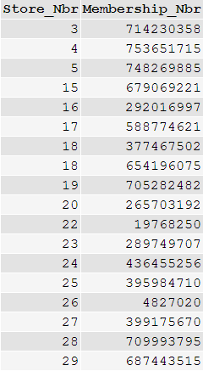

Query 5:

SELECT Store_Nbr, COUNT(Store_Nbr) AS FREQ FROM store_visits

GROUP BY Store_Nbr

HAVING COUNT(Store_Nbr) = (SELECT MAX(CNT) FROM (SELECT Store_Nbr, COUNT(Store_Nbr) as CNT FROM store_visits GROUP BY Store_Nbr) c)



Query 6:

SELECT a.Membership_Nbr, COUNT(*)

FROM

(SELECT Membership_Nbr, Store_Nbr FROM store_visits

GROUP BY Membership_Nbr, Store_Nbr) a

GROUP BY a.Membership_Nbr

HAVING COUNT(*) > 10

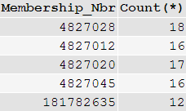

Query 7:

SELECT g.item_Nbr, item_desc.UPC_Desc, g.Total, g.Week FROM

(SELECT f.Total, f.Week, f.Item_Nbr FROM

(SELECT MAX(d.Total) Mega, d.Week FROM

(SELECT c.Item_Nbr, SUM(c.Total) Total, c.Week FROM

(SELECT a.Item_Nbr, a.Total, ROUND((EXTRACT(DAY FROM a.transaction_Date)-1)/7+1,0) Week

FROM

(SELECT x.Item_Nbr, x.Total, x.transaction_Date FROM

(SELECT Store_Nbr FROM store_information

WHERE State='FL') z

LEFT JOIN

(SELECT Store_Nbr, Item_Nbr, SUM(Item_Quantity) Total, transaction_Date FROM item_scan GROUP BY Item_Nbr, transaction_Date, Store_Nbr) x

ON z.Store_Nbr = x.Store_Nbr) a

LEFT JOIN

(SELECT Item_Nbr FROM item_desc GROUP BY Item_Nbr) b

ON a.Item_Nbr = b.Item_Nbr

WHERE EXTRACT(MONTH FROM Transaction_Date)=1 AND EXTRACT(YEAR FROM Transaction_Date)=2000) c

GROUP BY c.Item_Nbr, c.Week) d

GROUP BY d.Week) e

INNER JOIN

(SELECT c.Item_Nbr, SUM(c.Total) Total, c.Week FROM

(SELECT a.Item_Nbr, a.Total, ROUND((EXTRACT(DAY FROM a.transaction_Date)-1)/7+1,0) Week

FROM

(SELECT x.Item_Nbr, x.Total, x.transaction_Date FROM

(SELECT Store_Nbr FROM store_information

WHERE State='FL') z

LEFT JOIN

(SELECT Store_Nbr, Item_Nbr, SUM(Item_Quantity) Total, transaction_Date FROM item_scan GROUP BY Item_Nbr, transaction_Date, Store_Nbr) x

ON z.Store_Nbr = x.Store_Nbr) a

LEFT JOIN

(SELECT Item_Nbr FROM item_desc GROUP BY Item_Nbr) b

ON a.Item_Nbr = b.Item_Nbr

WHERE EXTRACT(MONTH FROM Transaction_Date)=1 AND EXTRACT(YEAR FROM Transaction_Date)=2000) c

GROUP BY c.Item_Nbr, c.Week) f

ON f.Week=e.Week and f.Total=e.Mega) g

LEFT JOIN item_desc

ON item_desc.Item_Nbr = g.Item_Nbr

ORDER BY g.WEEK

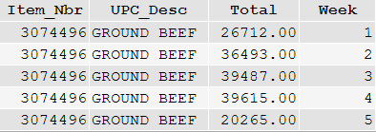

**Query 8:**

SELECT c.Vendor_Nbr, c.Store_Nbr FROM

(SELECT b.Store_Nbr, a.Vendor_Nbr, SUM(a.Total) Total2 FROM

(SELECT Store_Nbr FROM store_information WHERE State='FL') b

LEFT JOIN

(SELECT item_desc.Item_Nbr, item_desc.Vendor_Nbr, SUM(item_scan.Item_Quantity) Total, item_scan.Store_Nbr FROM item_desc

LEFT JOIN item_scan

ON item_scan.Item_Nbr = item_desc.Item_Nbr

GROUP BY item_desc.Item_Nbr, item_desc.Vendor_Nbr, item_scan.Store_Nbr) a

ON b.Store_Nbr = a.Store_Nbr

GROUP BY b.Store_Nbr, a.Vendor_Nbr) c

LEFT JOIN

(SELECT b.Store_Nbr, SUM(a.Total) TotalAll FROM

(SELECT Store_Nbr FROM store_information WHERE State='FL') b

LEFT JOIN

(SELECT item_desc.Item_Nbr, item_desc.Vendor_Nbr, SUM(item_scan.Item_Quantity) Total, item_scan.Store_Nbr FROM item_desc

LEFT JOIN item_scan

ON item_scan.Item_Nbr = item_desc.Item_Nbr

GROUP BY item_desc.Item_Nbr, item_desc.Vendor_Nbr, item_scan.Store_Nbr) a

ON b.Store_Nbr = a.Store_Nbr

GROUP BY b.Store_Nbr) d

ON c.Store_Nbr=d.Store_Nbr

WHERE Total2 > TotalAll*0.06

ORDER BY c.Vendor_Nbr, c.Store_Nbr

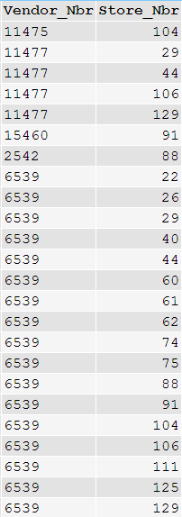

**APPENDIX:**

**TO GET Week**

SELECT ROUND((EXTRACT(DAY FROM Transaction_Date)-1)/7+1,0) AS Week, Transaction_Date FROM store_visits

WHERE EXTRACT(MONTH FROM Transaction_Date)=1 AND EXTRACT(YEAR FROM Transaction_Date)=2000